University of Wah
Department of Computer Science



Submit to:

Ms. Hassan Shafaqat

Submit by:

Muhammad Talha

Course:

Artificial Intelligence_Lab

Reg No:

UW-24-CS-BS-101

Section:

BS-CS-3rd-B

Task Graph
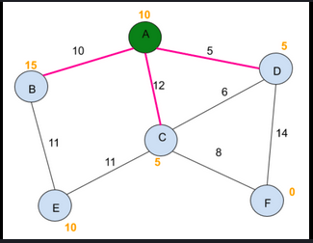
Task Code
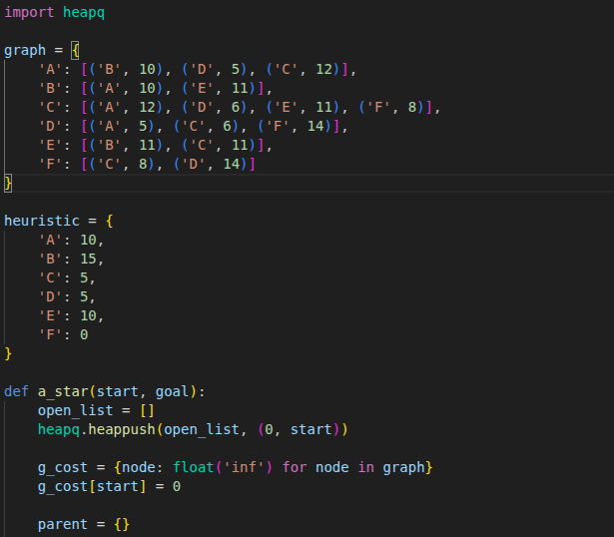

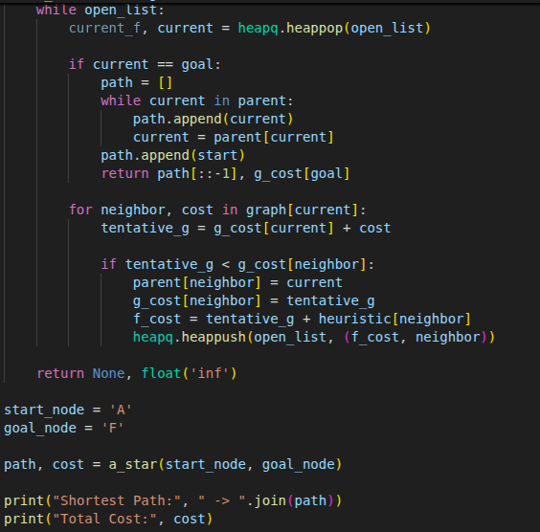
Output

